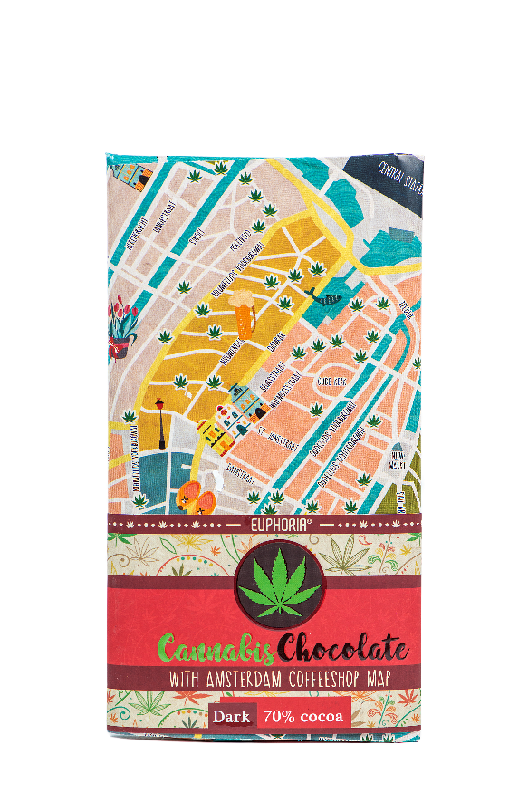

|  |
| --- |
| NAME |

#### Dark chocolate 70% with hemp seed

#### Dark chocolate with the addition of 10% cannabis seeds

#### Description: Rectangular chocolate rectangular cocoa bean table wrapped in aluminum foil and paper box

#### Country of origin: Czech Republic

|  |
| --- |
| MICROBIOLOGICAL PARAMETERS |

Rules of Good Manufacturing and Hygiene Practice - Microbiological Criteria for Food and internal regulations and standards:

|  |  |
| --- | --- |
| Total number of microorganisms / g ČSN ISO 4833 | < 5.103 |
| Mold / g ČSN ISO 7954 | < 101 |
| Salmonella spp./25g ČSN EN ISO 6579 | negat. |
| Enterobakterie/g ČSN ISO 7402/1995 | Max 5.102 | |

|  |  |
| --- | --- |
| PHYSICAL-CHEMICAL PARAMETERS | |
| According to internal standards and regulations: | |
| Contents total. cocoa solids in dark chocolate | min.70 % |
| **Content of hemp seed in the product** | **Max. 10 %** |
| THC content in hemp seed | Max. 0,02 % |

|  |
| --- |
| ORGANOLEPTIC PROPERTIES |

According to internal standards and regulations:

|  |  |
| --- | --- |
| Appearance | at a normal temperature of 20 ° C, a hard homogeneous mass, with a mixture of hemp. seeds |
| Color | dark brown with white cannabis seeds |
| Smell | chocolate, no foreign smell |
| Taste | bitterly chocolate, flavored with cannabis oil seeds, without foreign flavors |

|  |
| --- |
| COMPOSITION |

cocoa mass, sugar, cocoa powder with reduced fat peeled hemp seed (10%), cocoa butter, emulsifier (soy lecithin and polyglycerol oleate polyricin) MADAGASCAR BOURBON vanilla extract.

*The energy value is the value calculated according to the nutritional values of the raw materials used, it is not determined by the laboratory*

|  |  |
| --- | --- |
| energy value in 100 g of productfats           of which saturated fatty acidscarbohydrates     of which sugarsfiberproteins salt | 2287 kJ - 552 kcal  41 g  23 g  28 g  24g  11 g  11g  0,15 g |

|  |  |
| --- | --- |
| HYGIENIC PROPERTIES | |
| They are in line with the prospects. No. 305/2004 Coll. as amended, and Commission Regulation (EC) No 1881/2006, as amended | |
|  | PM (mg/kg) |
| Arsen | 0,5 |
| Lead | 1,0 |
| Mercury | 0,01 |

**The product complies with the requirements of EU Regulations 1829/03 and 1830/03, does not contain g.m.o.**

**The product complies with the quality and health requirements laid down in the Implementing Regulations to the Food Act No. 110/97 Coll.**

**MAY CONTAIN STAINS OF SOYA AND DRIED SKAFFLE PLANTS**